

* **CREATE TABLE-1**

CREATE TABLE CHALLAN_HEADER(

challan_id INT PRIMARY KEY, client_id INT,

challan_date DATE, total_amount DECIMAL

);

* **CREATE TABLE-2**

CREATE TABLE CHALLAN_DETAILS(

detail_id INT PRIMARY KEY, challan_id INT,

product_id INT, quantity INT, amount DECIMAL,

FOREIGN KEY(challan_id) REFERENCES CHALLAN_HEADER(challan_id)

);

* **INSERTION TABLE-1**

CREATE TABLE CHALLAN_HEADER(

challan_id INT PRIMARY KEY, client_id INT,

challan_date DATE, total_amount DECIMAL

);

* **INSERTION TABLE-2**

INSERT INTO CHALLAN_DETAILS VALUES (1,1,201,2,200.00),

(2,1,202,3,300.00),

(3,2,203,1,150.00),

(4,3,204,5,250.00);

SELECT * FROM CHALLAN_DETAILS;

# -- TASK

`

## -- query-1:

ALTER TABLE Product_Master

MODIFY COLUMN description VARCHAR(50) NOT NULL;

ALTER TABLE Product_Master

MODIFY COLUMN ProfitPercent INT NOT NULL;

ALTER TABLE Product_Master

MODIFY COLUMN SellPrice INT NOT NULL;

ALTER TABLE Product_Master

MODIFY COLUMN CostPrice INT NOT NULL;

## -- query-2

SELECT ProductNo, Description FROM Product_Master WHERE ProfitPercent BETWEEN 2 AND 3;

## ----------------------------------------------------------------------------------------------------------------------------------------------------------- TASK -

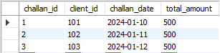

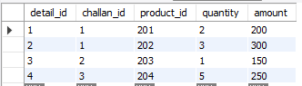

**TASK – QUERRY - 2**

